My name is Woonghee Lee. I am writing to formally request a retroactive withdrawal from my Math course for the Spring semester of 2023 due to unexpected and serious circumstances that adversely affected my ability to perform to my full potential in this class.

On the 11th of March, 2023, I was involved in a serious accident where I was hit by a car. This resulted in severe injuries to my left knee, particularly damaging my ACL/MCL, which required immediate medical attention and a lengthy recovery period. Following a visit to the emergency room, I was left incapacitated with a cast on my leg, unable to walk for two weeks. Beyond this period, I was required to use crutches for an additional two months.

My circumstances were further complicated by the fact that I am a commuter student. The round trip to the school, which normally takes me approximately 4 hours, became an immense struggle with the crutches, significantly impacting my ability to focus on my studies. Despite these challenges, I endeavored to keep up with my coursework as much as possible and, indeed, was able to maintain and even improve my performance in my other classes when compared to the previous semester.

Unfortunately, my performance in my Math class was not as successful. Math, as a subject, necessitates intense concentration, which was heavily impaired by the daily physical and emotional challenges I faced in the wake of my accident. It's important to stress that I have every confidence in my mathematical abilities and comprehension under normal circumstances. However, given the exceptional nature of my situation during this time, my performance fell below my usual standards and is not indicative of my true potential.

As I have made significant progress in my recovery, I am confident that I will devote the necessary time and energy to my Math course in a future semester and achieve the grades I am capable of. I believe it would be in the interest of my academic record and future career prospects to have the chance to demonstrate my full capabilities when I am physically able to do so.

I fully understand the seriousness of a retroactive withdrawal and would not be seeking one if not for these extraordinary circumstances. I have attached the relevant medical documents and hope the committee will favorably consider my application.

Thank you for taking the time to review my request. I am willing to provide any additional information required or meet in person to further discuss my situation if necessary.

Best regards,

Woonghee Lee

02003295

Attachment #1 – A picture of the document from the emergency room

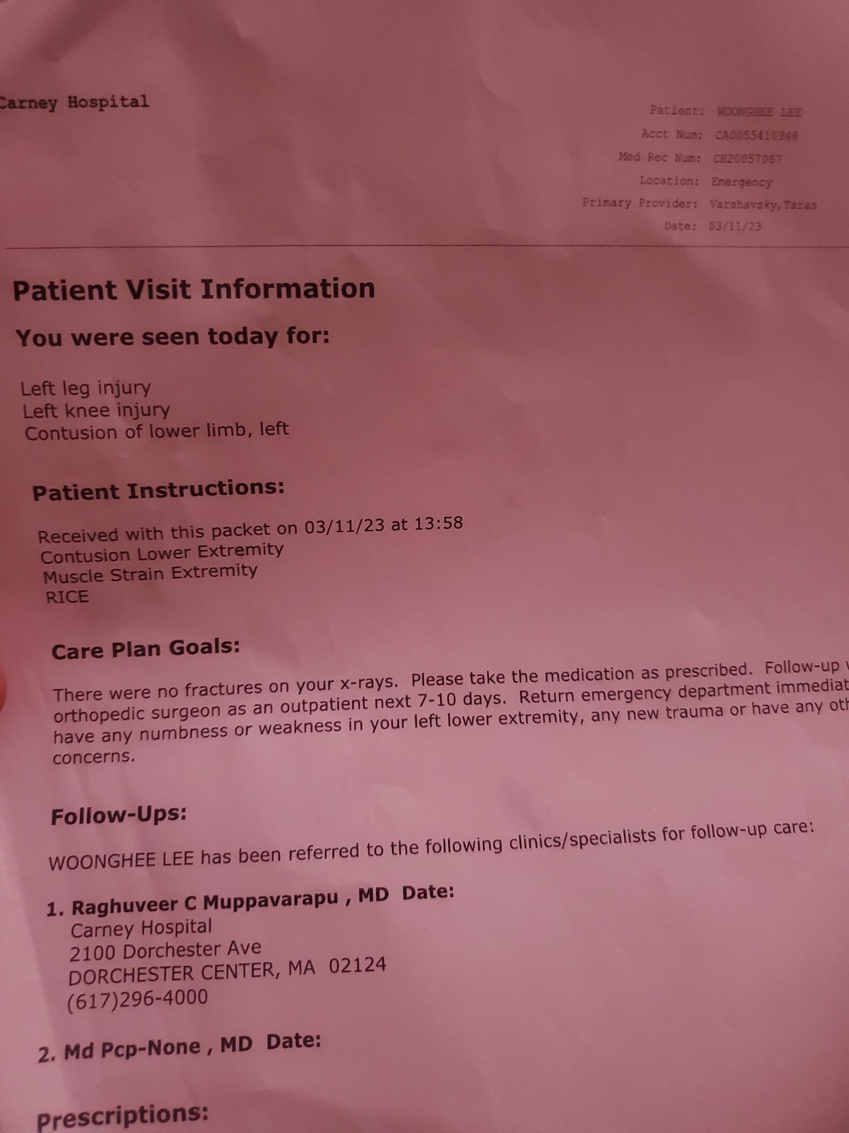

Attachment #2 – A referral order from the doctor(for Physical Therapy)

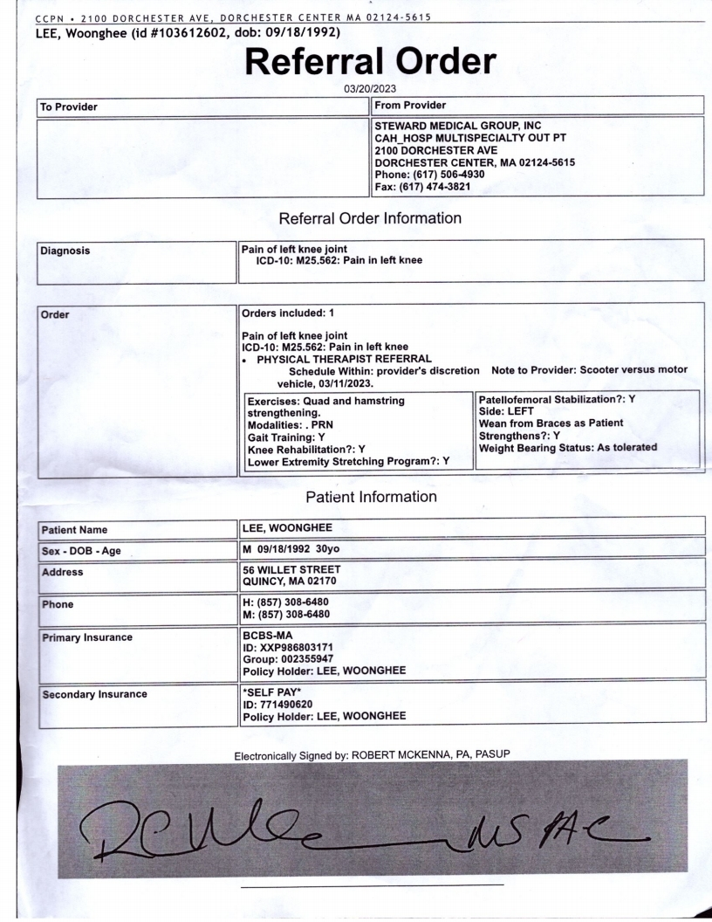

Attachment #3 – An imaging order from the doctor(for taking MRI)

